Chapter 11, Problem 55.

Using Fig. 11.74, design a problem to help other students better understand thee conservation of AC power.
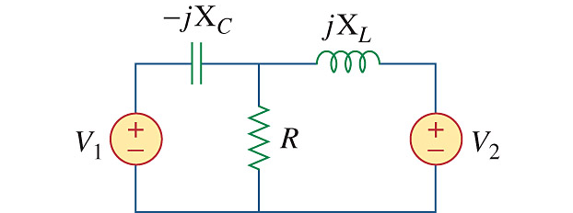

Figure 11.74
For Prob. 11.55.

